Angular Best Practices

General Coding Best Practices
Budeme používat Angular CLI
Npm install -g @angular/CLIE

Folder Structure
Delime nato zda se jedna o application component nebo feature component

Single Responsibility Principle
Jedna trida, metoda, funkce ma vždy jen jednu funkci
Immutability
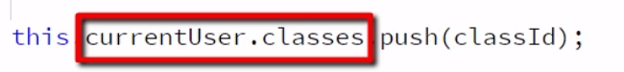
Menime CurrentUser classes tim ze z nej vyhazujeme classId, lepsi je priradit uplne novy object s tim ze classId proste jen vyhodime
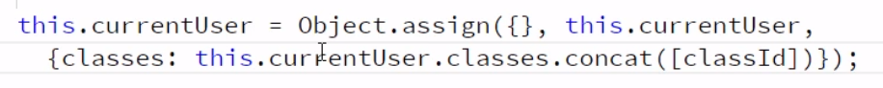
Podobny princip jako v ReactJs

Modules
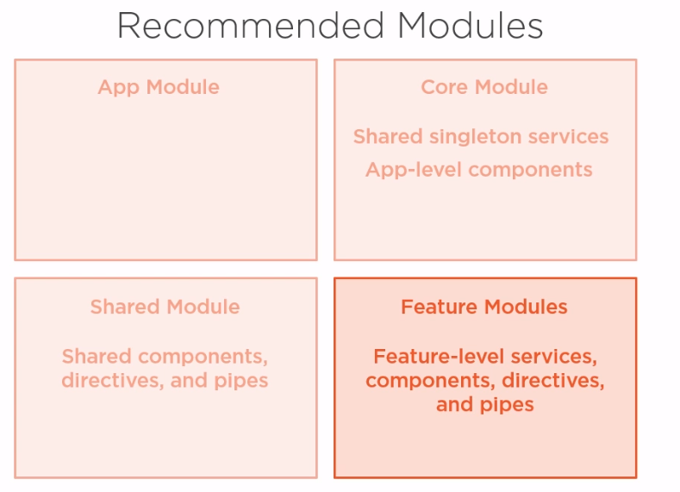
CoreModule – nav-bar atd

Services
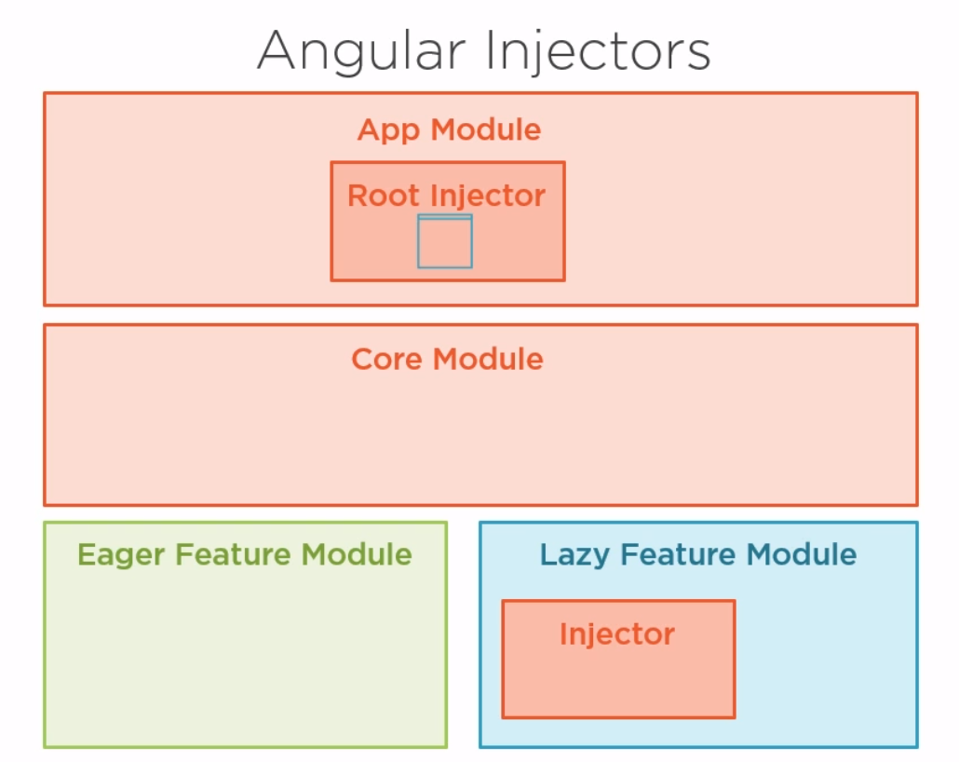
V core modulu mame singletony
Performance
Ahead-of-time Compilation
Do browseru se posila jen compiled application – pouzit Angular CLI, to to pouziva defaultne

Lazy loading
Chceme nacis modul v momente kdy na ni user klikne
V router.ts
import { Routes } from '@angular/router';
import { CatalogComponent } from './catalog/catalog.component';
import { RegisterComponent } from './users/register.component';
import { SignInComponent } from './users/sign-in.component';

export const appRoutes : Routes = [
{ path: 'catalog', component: CatalogComponent, },
{ path: 'users', loadChildren: 'app/users/users.module#UsersModule'} //rikame ze chceme user modul lazy loadovat
];

User.module.ts
import { NgModule } from '@angular/core';
import { ReactiveFormsModule, FormsModule } from '@angular/forms';
import { RouterModule } from '@angular/router';

import { SharedModule } from '../shared/shared.module';
import { RegisterComponent } from './register.component';
import { SignInComponent } from './sign-in.component';

@NgModule({
imports: [
ReactiveFormsModule,
FormsModule,
SharedModule,
RouterModule.forChild([//router pro lazy loading techto komponent
{ path: 'register', component: RegisterComponent, },
{ path: 'sign-in', component: SignInComponent, },
])
],
declarations: [ RegisterComponent, SignInComponent ],
exports: [ ],
providers: [ ]
})
export class UsersModule { };

funguje na principu, ze se nenacita cela zkompilovana stranka, ale pouze jeji casti

místo
Pouzit toto

Pure and Impure pipes
Pure – při zmene dat se neaktivuji
Impure – při zmene dat se aktivuji
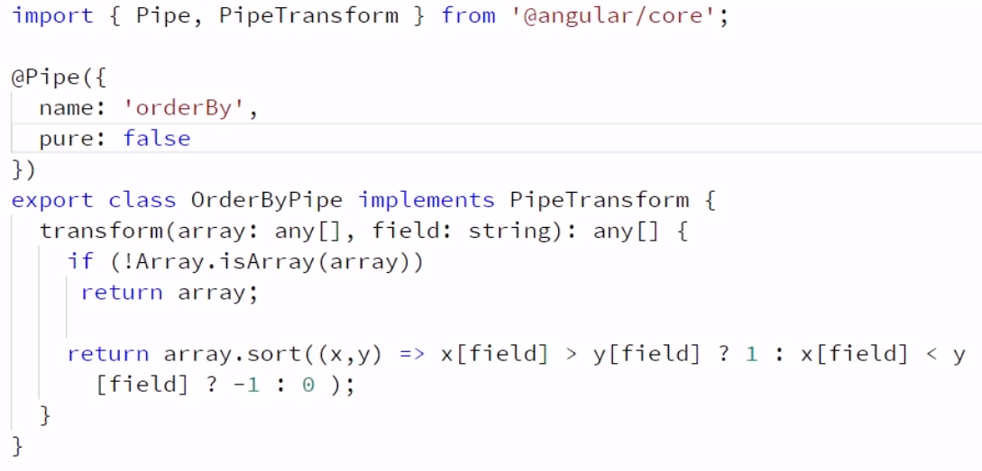
Pure na true není moc dobra praxe – dochazi k mnohocetnemu volani

